Chapter 17, Problem 39.

If the periodic voltage in Fig. 17.75(a) is applied to the circuit in Fig. 17.75(b), find i_{o}(t).

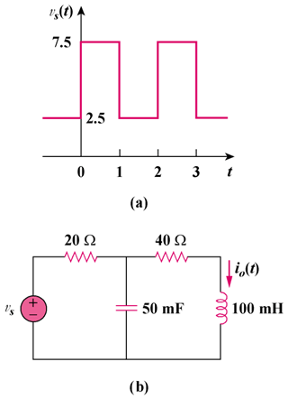

Figure 17.75
For Prob. 17.39.

